**Task 23**

Write Terraform script to create highly available infrastructure in AWS. The infra should have1 vpc, 3 subnets setup in 3 different az and 2 instances setup in 2 different subnets

Creating highly available infrastructure in AWS

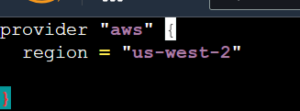

**Creating 1 VPC**

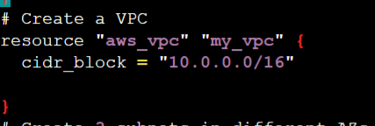

**Creating 3 Subnets in AZ**

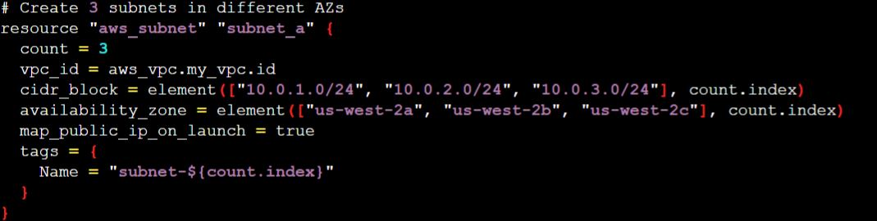

**Launching 2 instances with 2 subnets**



